**Drone (Quad-copter)**

A drone (quadcopter) is a flying device with four rotors, which helps it hover and move in any direction. It is controlled remotely or autonomously using a computer or GPS. Each rotor spins at different speeds to balance and steer the drone. Drones are used for photography, delivery, or surveillance. They have sensors and cameras to capture data and avoid obstacles.

* **Components Required:**

1. Pixhawk 2.4.8 Flight controller
2. FsiA10b Receiver
3. Fsi6X Transmitter
4. F450 Quadcopter frame
5. ESCs (BL-Heli 30A) - 4n
6. 1400kv 10T brushless motors – 4n
7. Propellers 9inch – 4n
8. Ublox Neo 7m GPS & compass module
9. Pixhawk Power module
10. GPS stand
11. Safety switch and Buzzer

* **Flight Controller:**

Flight controllers are essential for drones, each tailored to specific needs. The **Pixhawk 2.4.8** is a versatile

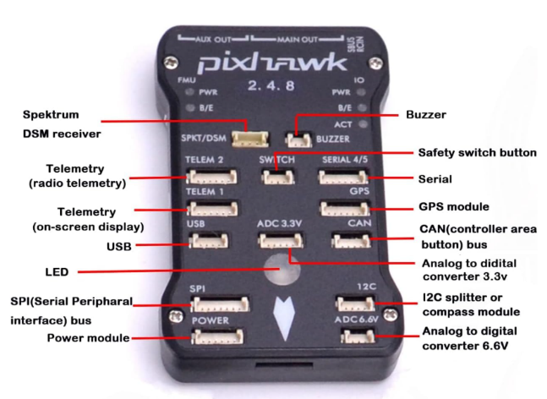and affordable option, supporting firmware like ArduPilot and PX4, making it ideal for various drones,

including quadcopters and VTOLs. It features a powerful processor, GPS, and telemetry support, making it a

favourite for projects requiring customization, autonomy, and reliability.

The **Kakute F7** is best for high-speed racing drones, with Betaflight support and built-in OSD for FPV,

though it’s less suited for complex applications. The **DJI Naza-M V2** offers easy setup and stable

performance, making it perfect for video drones but limited in customization.

Among these, **Pixhawk 2.4.8** stands out for its flexibility, advanced features, and support for larger drones

and autonomous missions, making it a top choice for diverse projects.

**Why Pixhawk 2.4.8?**

* 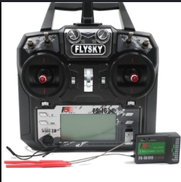Beginner Friendly
* Affordable and Reliable
* Open source and Flexible
* Good Sensor Suite
* Compatible with various soft wares (mission planner, Drone kit, etc..)
* **Receiver** (FS-iA10B) **& Transmitter** (Fs-i6x):

The **FS-iA10B** is a 10-channel receiver compatible with FlySky transmitters like the **FS-i6X**, offering a strong, interference-free connection using the **AFHDS 2A** (AutomPatic Frequency Hopping Digital System) protocol. It supports PWM and PPM/SBUS outputs, making it versatile for drones and RC vehicles, with a failsafe feature for added safety. The **FS-i6X** is a lightweight, affordable transmitter with an LCD for easy setup and supports advanced features like throttle curves. Together, they provide a reliable and user-friendly system for controlling drones, planes, and cars.

* 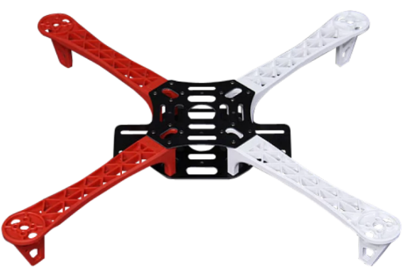**F450 quadcopter frame:**

The **F450 quadcopter frame** is a popular, lightweight frame made from durable glass fiber and nylon materials. It features a wheelbase of 450mm, ideal for medium-sized drones. The frame is compatible with standard motors, ESCs, and flight controllers, making it beginner-friendly. Its modular design ensures easy assembly and repair. The F450 is widely used for drone, including photography, FPV, and DIY builds.

* **Electronic Speed Controllers:**

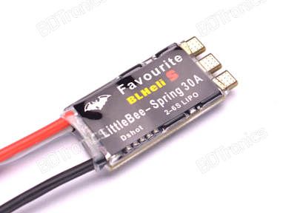**ESCs (Electronic Speed Controllers)** are devices that control the speed, direction, and braking of a drone's motors by regulating the power delivered from the battery. They are essential for translating signals from the flight controller into precise motor actions, enabling stable and responsive.

The **BLHeli 30A ESC** is a popular choice for drones due to its compatibility with BLHeli firmware, offering advanced features like smooth motor control and programmable settings. Its **30A current rating** makes it suitable for medium to large motors, providing enough power for drones with larger propellers or heavier payloads. Additionally, BLHeli ESCs support **OneShot125 and DShot protocols**, ensuring fast and accurate signal processing, critical for stable and agile flight performance.

* 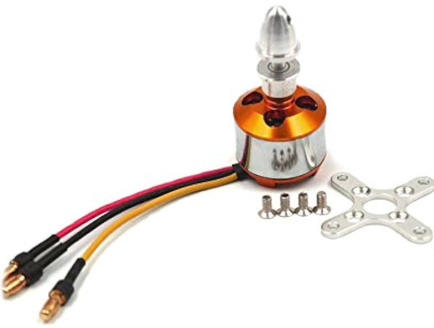**BLDC Motors and Propellers:**

**1400KV 10T brushless motors** with **9-inch propellers** is ideal for drones seeking a balance of power, stability, and efficiency. The **1400KV motors** provide good performance for medium-sized drones, offering stability for applications like aerial photography.

The **9-inch propellers** help lift heavier drones while maintaining smooth control. This setup works well for moderate speed and stable flight, especially for commercial tasks.

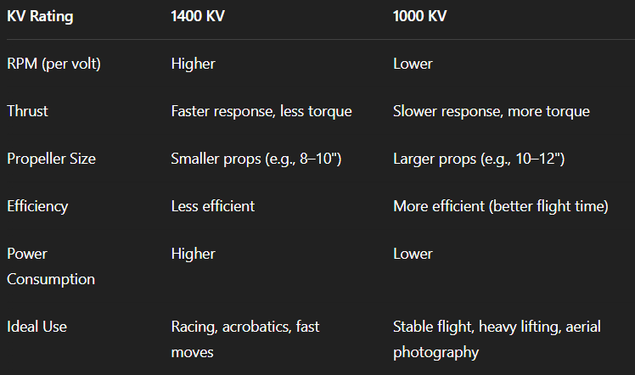

* 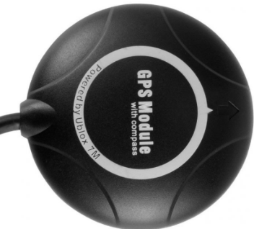**Ublox Neo 7m GPS & compass module**

The **u-blox NEO-7M GPS and compass module** can be integrated with the **Pixhawk 2.4.7** to provide accurate position data and orientation information for navigation. It enhances autonomous flight capabilities by offering GPS location tracking and compass heading for stable flight control.

* **Pixhawk Power module**

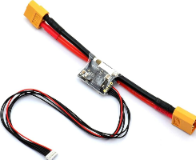A Pixhawk power module measures battery voltage, current, and power consumption, providing crucial data for monitoring battery health and flight performance. It connects directly to the Pixhawk and the battery to enable real-time power monitoring.

* **Safety switch and Buzzer**

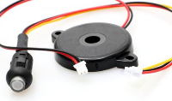The Pixhawk switch allows you to control the arming and disarming of the drone's motors. The buzzer provides audio feedback, indicating various system states such as arming, errors, or battery warnings.

* **Procedure:**
* Assemble the f450 frame as shown in the given picture and fix BLDC motors on the frame.
* Now connect the corresponding pins of motors to ESCs.
* Solder the positive and negative terminals of ESCs to PDB (power distribution board).
* Solder the Power module to PDB.
* 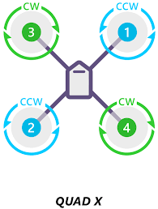Connect the power pins to PIXHAWK 2.4.8.
* Connect the GPS, Buzzer and safety switch.
* Fix propellers to motors as per the motor direction.

|  |  |
| --- | --- |
| Issues Faced | How to fix |
| Inconsistent Calibration(Accelerometer, compass, or gyro) | Calibrate on a flat, non-metallic surface |
| GPS Lock Problems | Test outdoors in open sky.  Make sure the **GPS + Compass module** is connected correctly (check TX/RX and I2C) |
| Telemetry Not Working,  No communication between ground station and drone | Incorrect COM port, faulty telemetry module, wrong baud rate  Ensure baud rate is 57600 or as per your module. |
| ESC Calibration Issues  (Motors don’t spin together or respond unevenly. ) | ESC calibration via Mission Planner. |
| Drone flips or wobbles on take-off | Motors connected in the wrong order or spinning the wrong way |
| **Failsafe Triggered Unexpectedly**  Drone disarms mid-air or refuses to arm | low battery, or bad GPS |
| Drone Not Arming  (Pre-arm check failed) | * Check pre-arm messages in Mission Planner. * Make sure GPS has lock and compass is calibrated. * Throttle stick down-left to arm (mode dependent). * Press safety switch if you're using one. |
| RC Transmitter Not Connecting | * Bind the receiver properly. |